Computer Language Coding Concepts

Interface Assignment in a Diagram
About the notation of assignment in general, see the article Assignment in a Diagram.

The principle of interface assignment is explained in the article Interface Assignment. This article demonstrates the expression of it in a diagram.

An assignment is a call to an assignment command, but the expression of an assignment call is given a more basic notation, like this:

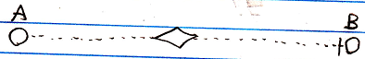

The fact, that the lines are dotted, expresses, that it is an interface assignment. The access mark indicates the direction. The target interface of symbol A is assigned to symbol B.

If you must have a character symbol for a class assignment, that distinguishes it from the other assignment types, it is a mix of an = and the letter i, which stands for interface.

This symbol is the identifier for interface assignment. You can also express it as i=.

See also: Assignment in a Diagram, Interface Assignment

Author & Copyright: Jan-Joost van Zon Date: July 13, 2008 – July 13, 2008 Location: Oosterhout, The Netherlands Status: Finished

